
Module Title
Principles of Programming
Weekly Assignment - Practical 9
Year
2025

Student Name: NIRVIK K.C.
UWE ID: 25024649
Assignment Submission Date: January 16, 2026

1
25024649
This assignment consists of the programming questions from practical exercises related to the topics from week 9.

Exercise 1: Understanding the basic concept of Inheritance
When you inherit from an existing class, you can reuse methods and fields of parent class, and further you can add new methods and fields also to your derived class.

1.
Task 1.1. Write the following program, study the code, save, compile, and run it.
/* file name should be Shape.py*/
Given code:
class Shape:
def displayShape(self):
print("Shape is displaying")

class Rectangle(Shape):
def displayRectangle(self):
print("Rectangle is displaying")
2
25024649
rec = Rectangle()
rec.displayShape()
rec.displayRectangle()

If you can successfully run your program, you should see the following output:
Shape is displaying
Rectangle is displaying

Answer:
Following code for input:
# Shape.py - Display the required shape
# Practical 9 - Exercise 1 (Task 1.1)
# Nirvik K.C.
class Shape:
def displayShape(self):
print("Shape is displaying")

3
25024649
# Class Rectangle inherits from Shape
class Rectangle(Shape):
def displayRectangle(self):
print("Rectangle is displaying")

# Create objects
rec = Rectangle()

# Call methods
rec.displayShape()
rec.displayRectangle()

# Output:
# Shape is displaying
# Rectangle is displaying

4
25024649
Output obtained in execution:
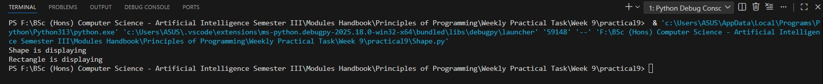

2.
Task 1.2. You may have noticed that no constructors are specifically given in the above code. Modify the above program by providing the constructors as below, save, compile, and run it.
Given code:
class Shape:
# constructor for Shape class
def __init__(self):
print("Shape constructor is called")
def displayShape(self):
print("Shape is displaying")
5
25024649
class Rectangle(Shape):
# constructor for Rectangle class
def __init__(self):
print("Rectangle constructor is called")

def displayRectangle(self):
print("Rectangle is displaying")

rec = Rectangle()
rec.displayShape()
rec.displayRectangle()

If you can successfully run your program, you should see the following output: Rectangle constructor is called
Shape is displaying
Rectangle is displaying
Observation: Unlike other OOP languages, like e.g., C++/Java, Python subclass does not call its base class constructor automatically.
6

25024649
Answer:
Following code for input:
# Showing constructors in inheritance
# Practical 9 - Exercise 1 (Task 1.2)
# Nirvik K.C.

class Shape:
# Constructor for Shape class
def __init__(self):
print("Shape constructor is called")

def displayShape(self):
print("Shape is displaying")

class Rectangle(Shape):
# Constructor for the class Rectangle
def __init__(self):
print("Rectangle constructor is called")
7
25024649
def displayRectangle(self):
print("Rectangle is displaying")

# Create objects of Rectangle class
rec = Rectangle()

# Call the methods
rec.displayShape()
rec.displayRectangle()

# Output:
# Rectangle constructor is called
# Shape is displaying
# Rectangle is displaying

8
25024649
Output obtained in execution:
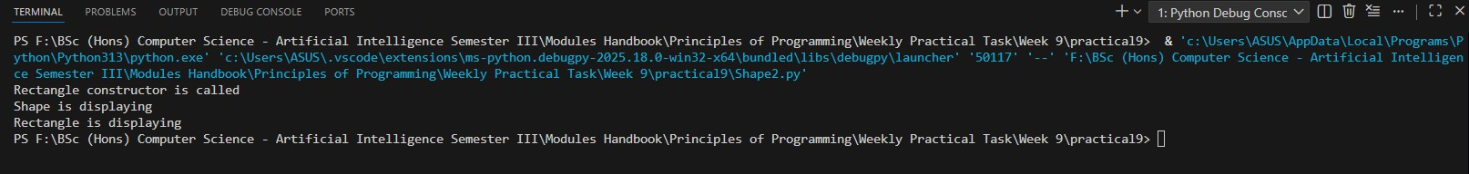

3.
Task 1.3. (Use of super) Modify the above program by calling Shape constructor in the Rectangle class using ‘super’ as below, save, compile, and run it.
Given code:
class Shape:
#constructor for Shape class
def __init__(self):
print("Shape constructor is called")

def displayShape(self):
print("Shape is displaying")
9

25024649
class Rectangle(Shape):
# constructor for Rectangle class, Base class constructor is called using '
super'
def __init__(self):
super().__init__()
print("Rectangle constructor is called")

def displayRectangle(self):
print("Rectangle is displaying")

rec = Rectangle()
rec.displayShape()
rec.displayRectangle()
If you can successfully run your program, you should see the following output: Shape constructor is called
Rectangle constructor is called
Shape is displaying
Rectangle is displaying
10
25024649
Can you explain what’s happening here and why? (Just write as a comment in the code).

Answer:
Following code for input:

class Shape:
# Constructor for Shape class
def __init__(self):
print("Shape constructor is called")

def displayShape(self):
print("Shape is displaying")

class Rectangle(Shape):
# constructor for Rectangle class, Base class constructor is called using 'super'
def __init__(self):
super().__init__()
11
25024649
print("Rectangle constructor is called")

def displayRectangle(self):
print("Rectangle is displaying")

# Output:
# Shape constructor is called
# Rectangle constructor is called
# Shape is displaying
# Rectangle is displaying

Output obtained in execution:
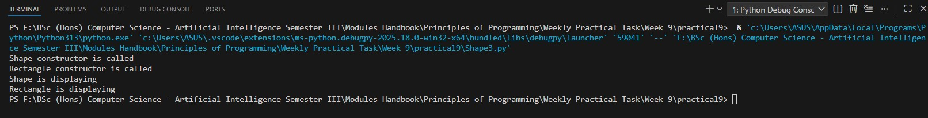

12
25024649
# Explanation of the output:

# First line of the output: "Shape constructor is called"
# Reason: Because inside the Rectangle.__init(), we wrote super().__init__() which tell Python to first run the parent's constructor.
# Second line of the output: "Rectangle constructor is called"
# Reason: The rest of Rectangle.__init__() after super() finished

# Third line of the output: "Shape is displaying"
# Reason: It is called from rec.displayShape() where displayShape() exits in the parent class (Shape). Class Rectangle inherited it, so it can be called on Rectangle objects

# Fourth line of the output: "Rectangle is displaying"
# Reason : This line is called from rec.displayRectangle(). The method is present in the Rectangle class, not Shape.

13
25024649
4.
Task 1.4. (Accessing base class public attributes in the subclass) Modify the above program by creating a public attribute “colour” in the base class and access it in the subclass as below, save, compile, and run it.
Given code:

class Shape:
# constructor for Shape class
def __init__(self, colour='Black'):
self.colour = colour
print("Shape constructor is called")

def displayShape(self):
print("Shape is displaying")

def getColour(self):
return self.colour

14
25024649
class Rectangle(Shape):
# constructor for Rectangle class, Base class constructor is called using 'super'
def __init__(self):
super().__init__()
print("Rectangle constructor is called")

def displayRectangle(self):
print("Rectangle is displaying")

def getRectangleColour(self):
return self.colour

rec = Rectangle()
print(rec.getRectangleColour())
If you can successfully run your program, you should see the following output: Shape constructor is called
Rectangle constructor is called
Black
15
25024649
Observation. Since ‘colour’ is a public member variable in the Shape class, it can be accessed anywhere, including in the subclass.
Answer:
Following code for input:
# Accessing base public attribute in subclass
# Practical 9 - Exercise 1 (Task 1.4)
# Nirvik K.C.
class Shape:
# constructor for Shape class
def __init__(self, colour='Black'):
self.colour = colour
print("Shape constructor is called")

def displayShape(self):
print("Shape is displaying")

def getColour(self):
return self.colour
16
25024649
class Rectangle(Shape):
# constructor for Rectangle class
# Parent class constructor is called using super()
def __init__(self):
super().__init__()
print("Rectangle constructor is called")

def displayRectangle(self):
print("Rectangle is displaying")

def getRectangleColour(self):
return self.colour # accessed the public attribute from parent

# Create Rectangle object
rec = Rectangle()

# Print the colour which is accessed from the public attribute
print(rec.getRectangleColour())
17
25024649
# Output:
# Shape constructor is called
# Rectangle constructor is called
# Black

Output obtained in execution:
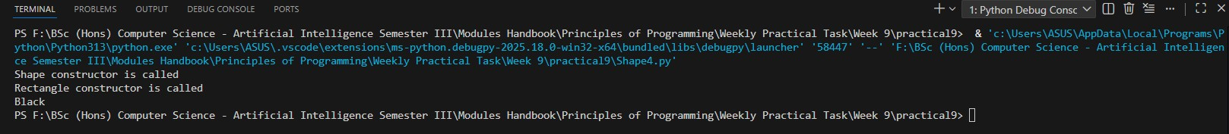

5.
Task 1.5: Now, in your code change the access modifier of “colour” variable according to the following and observe the corresponding results/outputs
(a) Task 1.5: self.__colour = colour # use a double underscore prefix
That is, make the variable as private and test your program as before if you can access it from the subclass.
18
25024649
Task 1.6 :
(b) self._colour = colour # use a single underscore prefix
That is, make the variable as protected and test your program as before if you can access it from the subclass.

Observation. Note that, a subclass does not inherit the private members of its base class. However, if the base class has public or protected methods for accessing its private fields, these can also be used by the subclass. Therefore, in this case you can use the following getRectangleColour() implementation to make it work.
def getRectangleColour(self):
return self.getColour()

(a) Task 1.5: self.__colour = colour # use a double underscore prefix
That is, make the variable as private and test your program as before if you can access it from the subclass.
Answer:
Following code for input:

19
25024649
# Testing private variable (double underscore) in inheritance
# Practical 9 - Exercise 1 - Task 1.5 (a)
# Nirvik K.C.

class Shape:
# Constructor - change the access modifier of “colour” variable
def __init__(self, colour='Black'):
# (a) Private attributes - use of double underscore
self.__colour = colour
print("Shape constructor is called")

# (b) Protected version - use of single underscore
# self._colour = colour
# print("Shape constructor is called")

def displayShape(self):
print("Shape is displaying")

20
25024649
# Public getter method read the private variable
def getColour(self):
return self.__colour

class Rectangle(Shape):
def __init__(self):
super().__init__()
print("Rectangle constructor is called")

def displayRectangle(self):
print("Rectangle is displaying")

# This method tries to access colour
def getRectangleColour(self):
# Direct access to private variable using parent's public getter
return self.getColour()

21
25024649
# Create Rectangle object
rec = Rectangle()

# Using inherited method
rec.displayShape()

# Using Rectangle's own method
rec.displayRectangle()

# Print the colour
print("Colour: ", rec.getRectangleColour())

# Direct access of the private attributes does not change the value
rec.__colour = "Red"

# Print the colour after change - Still Black
print("New Colour: ", rec.getRectangleColour())

22
25024649
# Output:
# Shape constructor is called
# Rectangle constructor is called
# Shape is displaying
# Rectangle is displaying
# Colour: Black
# New Colour: Black

Output obtained in execution:
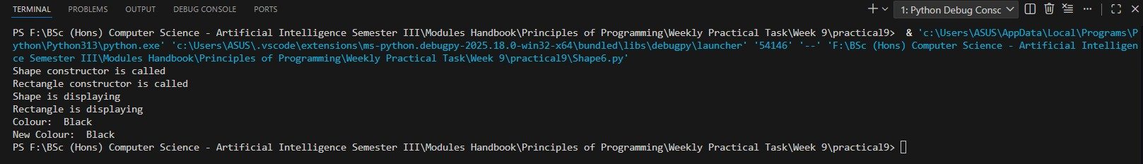

23
25024649
(b) 1.6: self._colour = colour # use a single underscore prefix
That is, make the variable as protected and test your program as before if you can access it from the subclass.

Answer:
Following code for input:
# Testing protected member variable with single underscore
# Practical 9 - Exercise 1 - Task 1.5 (b)
# Nirvik K.C.

class Shape:
# Constructor - change the access modifier of “colour” variable
def __init__(self, colour = 'Black'):
# (b) Protected attributes - use of single underscore
self._colour = colour
print("Shape constructor is called")

24
25024649
# (a) Private attributes - use of double underscore
# self.__colour = colour
# print("Shape constructor is called")

def displayShape(self):
print("Shape is displaying")

# Public getter used to read the protected variable
def getColour(self):
return self._colour

class Rectangle(Shape):
def __init__(self):
super().__init__()
print("Rectangle constructor is called")

def displayRectangle(self):
print("Rectangle is displaying")
25
25024649
# Method which accessed the protected variable 'colour' directly
def getRectangleColour(self):
return self._colour

# Create Rectangle object
rec = Rectangle()

# Using inherited method
rec.displayShape()

# Using Rectangle's own method
rec.displayRectangle()

# Print the colour
print("Colour: ", rec.getRectangleColour())

# Direct access of the private attributes does not change the value
rec._colour = "Red"
26
25024649
# Print the colour after change - Still Black
print("New Colour: ", rec.getRectangleColour())

# Output:
# Shape constructor is called
# Rectangle constructor is called
# Shape is displaying
# Rectangle is displaying
# Colour: Black
# New Colour: Red

Output obtained in execution:
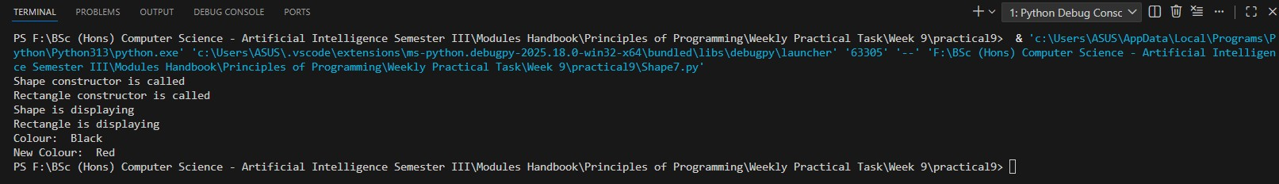
27

25024649
7.
Task 1.7: (Use of Polymorphism: overriding method) Modify the above program according to the following:
In the Shape class, change the displayShape(self) method name to display(self) In the Rectangle class, change the displayShape(self) method name to display(self) Then call the display() method using a rectangle object as below.
Given code:
class Shape:
#constructor for Shape class
def __init__(self, colour='Black'):
self.colour = colour
print("Shape constructor is called")

def display(self):
print("Shape is displaying")

def getColour(self):
return self.colour

28
25024649
class Rectangle(Shape):
# constructor for Rectangle class, Base class constructor is called using '
super'
def __init__(self):
super().__init__()
print("Rectangle constructor is called")

def display(self):
print("Rectangle is displaying")

def getRectangleColour(self):
return self.getColour()

rec = Rectangle()
print(rec.getRectangleColour())
rec.display()

29
25024649
If you can successfully run your program, you should see the following output:
Shape constructor is called
Rectangle constructor is called
Black
Rectangle is displaying

Answer:
Following code for input:
# Use of Polymorphism: overriding method
# Practical 9 - Exercise 1 - Task 1.7
# Nirvik K.C.

class Shape:
# Constructor for Shape Class
def __init__(self, colour='Black'):
self.colour = colour
print("Shape constructor is called")

30
25024649

def display(self):
print("Shape is displaying")

def getColour(self):
return self.colour

class Rectangle(Shape):
# Constructor for Rectangle class
def __init__(self):
super().__init__()
print("Rectangle constructor is called")

def display(self):
print("Rectangle is displaying")

def getRectangleColour(self):
return self.getColour()
31
25024649
# Create Rectangle object
rec = Rectangle()

# Print the colour using getter
print(rec.getRectangleColour())

# Call display() on Rectangle object
rec.display()

# Output:
# Shape constructor is called
# Rectangle constructor is called
# Black
# Rectangle is displaying

32
25024649
Output obtained in execution:
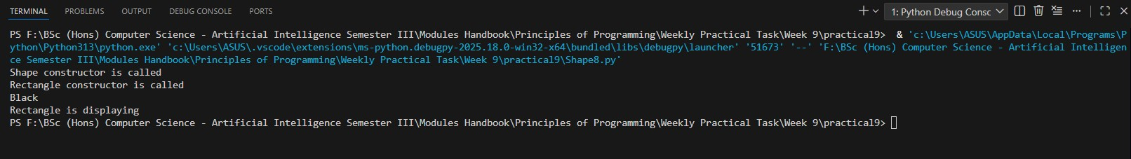

Observation: Note that both versions of the display() method are members of the Rectangle class. However, in the output you see Rectangle is displaying (and not the Shape is displaying).
Can you explain, why? (Just write as a comment in the code).
Answer:

# Explanation of output order and why "Rectangle is displaying" is shown (not "Shape is displaying")
# Reason: This is an example of method overriding in polymorphism.
# The Rectangle class inherits from Shape and overrides the display() method.
# When rec.display() is called on a Rectangle object, Python looks for the method in the Rectangle class first.
33
25024649
# Since Rectangle has its own display() method, it executes that instead of the one in Shape.
# This is why "Rectangle is displaying" is printed instead of "Shape is displaying."

8.
Task 1.8: (Use of Polymorphism: overriding method) Now create another Square subclass of the Shape class with an empty body according to the following. Create an instance of the Square class and call the display() method using that object. Run your code and explain the output to your tutors.
Given code:
class Shape:
#constructor for Shape class
def __init__(self, colour='Black'):
self.colour = colour
print("Shape constructor is called")

def display(self):
print("Shape is displaying")
34
25024649
def getColour(self):
return self.colour

class Rectangle(Shape):
#constructor for Rectangle class, Base class constructor is called using '
super'
def __init__(self):
super().__init__()
print("Rectangle constructor is called")

def display(self):
print("Rectangle is displaying")

def getRectangleColour(self):
return self.getColour()

class Square(Shape):
pass
35
25024649
rec = Rectangle()
print(rec.getRectangleColour())
rec.display()
sqr = Square()
sqr.display()

Answer:
Following code for input:
# Polymorphism & overriding with empty subclass
# Practical 9 - Exercise 1 - Task 1.8
# Nirvik K.C.

class Shape:
# Constructor for Shape class
def __init__(self, colour='Black'):
self.colour = colour
print("Shape constructor is called")
36
25024649
def display(self):
print("Shape is displaying")

def getColour(self):
return self.colour

class Rectangle(Shape):
# Constructor for Rectangle class
def __init__(self):
super().__init__()
print("Rectangle constructor is called")

# Overrides the display() method from Shape
def display(self):
print("Rectangle is displaying")

def getRectangleColour(self):
return self.getColour()
37
25024649
class Square(Shape):
# Empty body with no constructor or method defined
# Inherits everything from Shape class
pass

# Create a Rectangle object
rec = Rectangle()

# Call display() on Rectangle object - uses Rectangle's overridden method
rec.display()

# Create a Square object
sqr = Square()

# Call display() on Square object - inherits method from Shape
sqr.display()

38
25024649
# Output:
# Shape constructor is called
# Rectangle constructor is called
# Rectangle is displaying
# Shape constructor is called
# Shape is displaying

Output obtained in execution:
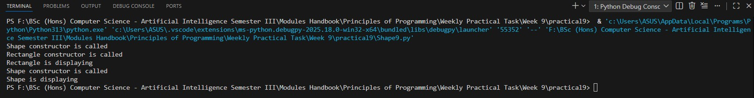

39
25024649
9.
Task 1.9: (Use of Polymorphism: overriding method) Now using your Square
object call the getRectangleColour() method of the rectangle class as below. Run your code and explain the output to your tutors.
Given code:
rec = Rectangle()
print(rec.getRectangleColour())
rec.display()
sqr = Square()
sqr.display()
sqr.getRectangleColour()

Answer:
Following code for input:
# Polymorphism & calling subclass method on unrelated object
# Practical 9 - Exercise 1 - Task 1.9
# Nirvik K.C.

40
25024649
class Shape:
# Constructor for Shape class
def __init__(self, colour='Black'):
self.colour = colour
print("Shape constructor is called")

def display(self):
print("Shape is displaying")

def getColour(self):
return self.colour

class Rectangle(Shape):
# Constructor for Rectangle class
def __init__(self):
super().__init__()
print("Rectangle constructor is called")

41
25024649
# Overrides the display() method from Shape
def display(self):
print("Rectangle is displaying")

def getRectangleColour(self):
return self.getColour()

class Square(Shape):
# Empty body with no constructor or method defined
# Inherits everything from Shape class
pass

# Create a Rectangle object
rec = Rectangle()

# Call the getRectangleColour() method of the rectangle class
print(rec.getRectangleColour())

42
25024649
# Call display() on Rectangle object - uses Rectangle's overridden method
rec.display()

# Create a Square object
sqr = Square()

# Call display() on Square object - inherits method from Shape
sqr.display()

# Call method - getRectangleColour() on Square object
sqr.getRectangleColour()

# Output(until the error):
# Shape constructor is called
# Rectangle constructor is called
# Black
# Rectangle is displaying
# Shape constructor is called
43
25024649
# Shape is displaying
# AttributeError: 'Square' object has no attribute 'getRectangleColour'

Output obtained in execution (until the error):
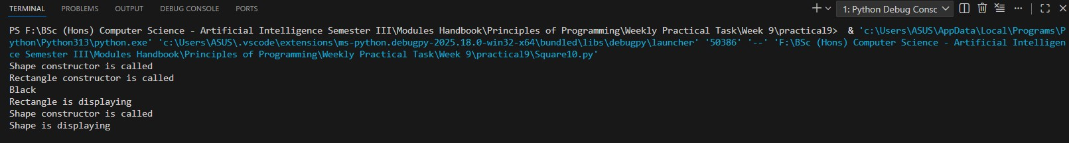

The Error Message:
AttributeError: 'Square' object has no attribute 'getRectangleColour'

44
25024649
The Message Shown:
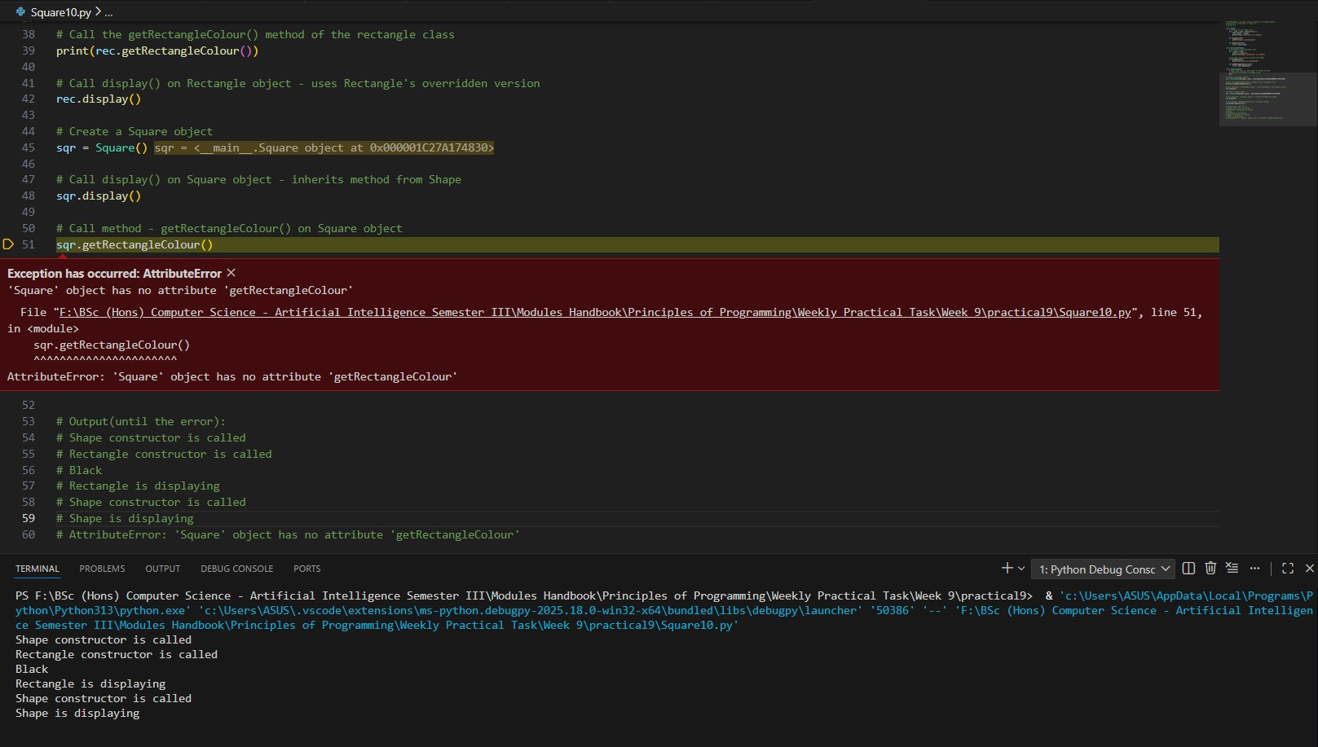

45
25024649
Explain the output and error:
When rec = Rectangle() is executed, the Rectangle constructor runs first and calls super().__init__(), which triggers the Shape constructor. This prints out “Shape constructor is called”. After the parent finishes, the Rectangle constructor continues and prints out “Rectangle constructor is called.” Then rec.getRectangleColour() return ‘Black’ (set in Shape). Finally, rec.display() uses Rectangle’s overridden method that prints out “Rectangle is displaying.” The Square() method has no display, so it uses inherited display() from Shape which prints out “Shape is displaying”. The sqr.getRectangleColour() method exist only in Rectangle class and Square does not inherit it from Rectangle (only from Shape). So, python cannot find the getRectangleColour() which results in AttributeError. Therefore, methods defined in one subclass (Rectangle) are not automatically available in another subclass (Square).

46
25024649
Exercise 2: Design and Implementation
Your starting point will be to consider a simple example based on people. Suppose you are developing a software system for UWE. They have already designed, written, coded and tested a class called Person. An object in this class holds personal information about somebody using his name and address. A Person also has methods that can construct a new person from given data, print the information in a standard format, set the name and address and so on. Now UWE also wants a Lecturer class, a Student class, and a GraduateStudent class that are all different kinds of People!
A UML class diagram of the Person class and its corresponding Python code implementation are shown below. Note that all the member variables are private and methods are public.
-firstName: String
-lastName: String
-address: String

- fuelLevel: float

Person

+Person()
+Person(firstName: String, lastName: String, address: String)
+setFirstName(firstName: String): void
+getFirstName(): String
+setLastName(lastName: String): void
+getLastName(): String
+setAddress(address: String): void
+getAddress(): String
+__str_(): String

- fuelLevel: float

47
25024649
Given code:
class Person:
# constructor
def __init__(self, firstName='Mr', lastName='X', address='Bristol'):
self.__firstName = firstName #private variable
self.__lastName = lastName #private variable
self.__address = address #private variable

def setFirstName(self, firstName):
self.__firstName = firstName

def setLastName(self, lastName):
self.__lastName = lastName

def setAddress(self,address):
self.__address = address

48
25024649
def getFirstName(self):
return self.__firstName

def getLastName(self):
return self.__lastName

def getAddress(self):
return self.__address

def __str__(self):
return "Person's name is " + self.getFirstName() +" "+ self.getLastNam
e() +"\nAddress is "+ self.getAddress()
# creating a Person object with default values
print("Creating a Person object with default values")
p = Person()
# printing the information using __str__ method
print("Printing the information using __str__ method")
print(p)
49
25024649
# setting name and address
print("Now setting the names and address")
p.setFirstName("Abdur")
p.setLastName("Rakib")
p.setAddress("UWE Frenchay Campus 4QXX")
#printing the information using __str__ method
print("Printing the information using __str__ method")
print(p)
#Creating another object by passing the values explicitly
print("Creating another Person object by passing the values explicitly")
p1 = Person("Jun", "Hong", "UWE Frenchay Campus 3QXX")
#printing the information using __str__ method
print("Printing the information using __str__ method")
print(p1)

10. Task 2.1: Study the Person class diagram and the corresponding Python code. Write, save, compile, and run the above code.
/* file name should be Person.py*/
50
25024649
Answer:
Following code for input:
# Person class with private attributes and __str__
# Practical 9 - Exercise 2 - Task 2.1
# Nirvik K.C.
class Person:
# Constructor with default values
def __init__(self, firstName='Mr', lastName='X', address='Bristol'):
self.__firstName = firstName # private variable
self.__lastName = lastName # private variable
self.__address = address # private variable

# Setters
def setFirstName(self, firstName):
self.__firstName = firstName

def setLastName(self, lastName):
self.__lastName = lastName
51
25024649
def setAddress(self, address):
self.__address = address

# Getters
def getFirstName(self):
return self.__firstName

def getLastName(self):
return self.__lastName

def getAddress(self):
return self.__address

# Use of __str__method
def __str__(self):
return "Person's name is " + self.getFirstName() +" "+ self.getLastName() +"\nAddress is "+ self.getAddress()

52
25024649
# Test program

# Creating a Person object with default values
print("Creating a Person object with default values")
p = Person()

# Printing the information using __str__ method
print("Printing the information using __str__ method")
print(p)

# Setting name and address
print("Now setting the names and address")
p.setFirstName("Abdur")
p.setLastName("Rakib")
p.setAddress("UWE Frenchay Campus 4QXX")

53
25024649
# Printing the information using __str__ method
print("Printing the information using __str__ method")
print(p)

# Creating another object by passing values explicitly
print("Creating another Person object by passing the values explicitly")
p1 = Person("Jun", "Hong", "UWE Frenchay Campus 3QXX")

# Printing the information using __str__ method
print("Printing the information using __str__ method")
print(p1)

# Output:
# Creating a Person object with default values
# Printing the information using __str__ method
# Person's name is Mr X
# Address is Bristol
# Now setting the names and address
54
25024649
# Printing the information using __str__ method
# Person's name is Abdur Rakib
# Address is UWE Frenchay Campus 4QXX
# Creating another Person object by passing the values explicitly
# Printing the information using __str__ method
# Person's name is Jun Hong
# Address is UWE Frenchay Campus 3QXX

Output obtained in execution:
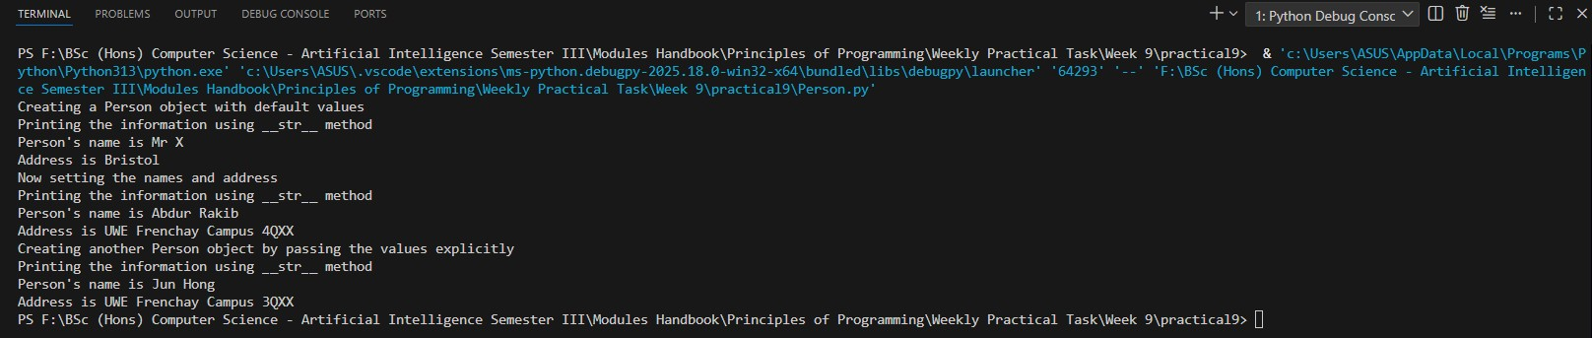

55
25024649
11.
Task 2.2: Design three classes Lecturer, Student, and GraduateStudent using pen and paper (or you can use MS Word/PowerPoint editor). The classes Lecturer and Student extend/inherit Person, and GraduateStudent extends/inherits Student. Draw the complete UML class diagram considering all the four classes. Your three newly designed classes contain the following:

Lecturer class:
• One private integer data field representing lecturer ID
• Appropriate constructor that creates a lecturer with the specified name, address, and the lecturer ID (note that you need to access name and address from the base class)
• All the appropriate ‘set’ and ‘get’ methods
• A method named __str__() that returns a string description for the lecturer. It will use the base class __str__()

Student class:
• One private integer data field representing student ID

56
25024649
• Appropriate constructor that creates a student with the specified name, address, and the student ID (note that you need to access name and address from the base class)
• All the appropriate ‘set’ and ‘get’ methods
• A method named __str__() that returns a string description for the lecturer. It will use its base class __str__()

GraduateStudent class:
• One private String data field representing supervisor’s name (usually, a graduate student works under an assigned supervisor)
• Appropriate constructor that creates a graduate student with the specified name, address, the student ID, and the supervisor’s name (note that you need to access name, address, and student ID from the base class)
• All the appropriate ‘set’ and ‘get’ methods
• A method named __str__() that returns a string description for the lecturer. It will use its base class __str__()

Answer:
UML Diagram for the all four classes:

57
25024649
Person
-firstName: String
-lastName: String
-address: String

+Person()
+Person(firstName: String, lastName: String, address: String)
+setFirstName(firstName: String): void
+getFirstName(): String
+setLastName(lastName: String): void
+getLastName(): String
+setAddress(address: String): void
+getAddress(): String
+__str_(): String

58
+ GraduateStudent(firstName: String, lastName: String, address: String, studentID: int, supervisor: String)
+ setSupervisor(name: String): void
+ getSupervisor(): String
+ __str__(): String

- __supervisor: String

GraduateStudent

+ Lecturer(firstName: String, lastName: String, address: String, lecturerID: int)
+ setLecturerID(id: int): void
+ getLecturerID(): int
+ __str__(): String

Person
Lecturer
+ Student(firstName: String, lastName: String, address: String, studentID: int)
+ setStudentID(id: int): void
+ getStudentID(): int
+ __str__(): String

- __studentID: int

- __lecturerID: int

25024649
Following code for input:
# Inheritance with Person, Lecturer, Student, GraduateStudent
# Practical 9 - Exercise 2 - Task 2.2
# Nirvik K.C.
class Person:
def __init__(self, firstName="Mr", lastName="X", address="Bristol"):
self.__firstName = firstName
self.__lastName = lastName
self.__address = address

# Setters
def setFirstName(self, firstName):
self.__firstName = firstName

def setLastName(self, lastName):
self.__lastName = lastName

59
25024649
def setAddress(self, address):
self.__address = address

# Getters
def getFirstName(self):
return self.__firstName

def getLastName(self):
return self.__lastName

def getAddress(self):
return self.__address

# __str__ method
def __str__(self):
return f"Person's name is {self.getFirstName()} {self.getLastName()}\nAddress is {self.getAddress()}"

60
25024649
class Lecturer(Person):
def __init__(self, firstName, lastName, address, lecturerID):
super().__init__(firstName, lastName, address)
self.__lecturerID = lecturerID

# Getters and setters for lecturerID
def getLecturerID(self):
return self.__lecturerID

def setLecturerID(self, lecturerID):
self.__lecturerID = lecturerID

# Override __str__
def __str__(self):
return super().__str__() + f"\nLecturer ID: {self.getLecturerID()}"

61
25024649
class Student(Person):
def __init__(self, firstName, lastName, address, studentID):
super().__init__(firstName, lastName, address)
self.__studentID = studentID

# Getters and setters for studentID
def getStudentID(self):
return self.__studentID

def setStudentID(self, studentID):
self.__studentID = studentID

# Override __str__
def __str__(self):
return super().__str__() + f"\nStudent ID: {self.getStudentID()}"

62
25024649
class GraduateStudent(Student):
def __init__(self, firstName, lastName, address, studentID, supervisor):
super().__init__(firstName, lastName, address, studentID)
self.__supervisor = supervisor

# Getters and setters for supervisor
def getSupervisor(self):
return self.__supervisor

def setSupervisor(self, supervisor):
self.__supervisor = supervisor

# Override __str__
def __str__(self):
return super().__str__() + f"\nSupervisor: {self.getSupervisor()}"

63
25024649
# Lecturer
lec = Lecturer("Dr. Wilson", "Smith", "London", 101)
print(lec)
print()

# Student
stu = Student("Harry", "Conway", "Bristol", 239201)
print(stu)
print()

# GraduateStudent
grad = GraduateStudent("Joe", "Clark", "Manchester", 2023002, "Prof. David")
print(grad)

64
25024649
Output obtained in execution:
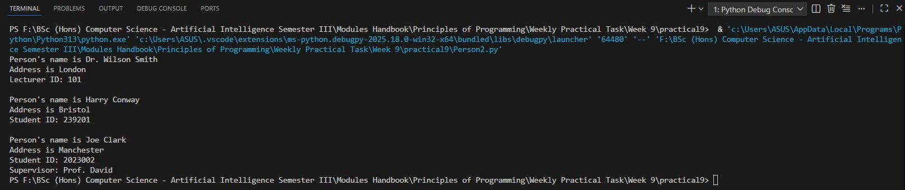

12.
Task 2.3: Implement your classes, create appropriate objects and print the information. For example, you should create objects and print the information like this:
lecturer = Lecturer ("Chris", " Simons", "UWE Frenchay Campus 4QXX",2345); print(lecturer);
student = Student ("Peter", "Miller","UWE Frenchay Campus",5678); print(student);
65
25024649
gradstudent = GraduateStudent ("Dan", "Fielding", "UWE Frenchay Campus",6789,"Jim Smith");
print(gradstudent);

Output:
Lecturer's name is Chris Simons
Address is UWE Frenchay Campus 4QXX
Lecturer ID: 2345
Students's name is Peter Miller
Address is UWE Frenchay Campus
Student ID: 5678
Students's name is Dan Fielding
Address is UWE Frenchay Campus
Student ID: 6789
Supervisor’s name: Jim Smith

Answer:
Following code for input:
66
25024649
# Implement your classes, create appropriate objects and print the information
# Practical 9 - Exercise 2 - Task 2.3
# Nirvik K.C.
class Person:
def __init__(self, firstName="Mr", lastName="X", address="Bristol"):
self.__firstName = firstName
self.__lastName = lastName
self.__address = address

# Getters
def getFirstName(self):
return self.__firstName

def getLastName(self):
return self.__lastName

def getAddress(self):
return self.__address
67
25024649
# __str__ method
def __str__(self):
return f"{self.getFirstName()}'s name is {self.getFirstName()} {self.getLastName()}\n" f"Address is {self.getAddress()}"

class Lecturer(Person):
def __init__(self, firstName, lastName, address, lecturerID):
super().__init__(firstName, lastName, address)
self.__lecturerID = lecturerID

# Override __str__
def __str__(self):
return "Lecturer's name is " + self.getFirstName() + " " + self.getLastName() + "\n" "Address is " + self.getAddress() + "\n" "Lecturer ID: " + str(self.__lecturerID)

68
25024649
class Student(Person):
def __init__(self, firstName, lastName, address, studentID):
super().__init__(firstName, lastName, address)
self.__studentID = studentID

# Override __str__
def __str__(self):
return "Student's name is " + self.getFirstName() + " " + self.getLastName() + "\n" "Address is " + self.getAddress() + "\n" "Student ID: " + str(self.__studentID)

class GraduateStudent(Student):
def __init__(self, firstName, lastName, address, studentID, supervisor):
super().__init__(firstName, lastName, address, studentID)
self.__supervisor = supervisor
# Override __str__
def __str__(self):
return "Student's name is " + self.getFirstName() + " " + self.getLastName() + "\n" "Address is " + self.getAddress() + "\n" + "Student ID: " + str(self._Student__studentID) + "\n" "Supervisor’s name: " + self.__supervisor
69
25024649
# Lecturer
lecturer = Lecturer("Chris", "Simons", "UWE Frenchay Campus 4QXX", 2345)
print(lecturer)

# Student
student = Student("Peter", "Miller", "UWE Frenchay Campus", 5678)
print(student)

# GraduateStudent
gradstudent = GraduateStudent("Dan", "Fielding", "UWE Frenchay Campus", 6789, "Jim Smith")
print(gradstudent)

# Output:
# Lecturer's name is Chris Simons
# Address is UWE Frenchay Campus 4QXX
# Lecturer ID: 2345
# Student's name is Peter Miller
70
25024649
# Address is UWE Frenchay Campus
# Student ID: 5678
# Student's name is Dan Fielding
# Address is UWE Frenchay Campus
# Student ID: 6789

Output obtained in execution:
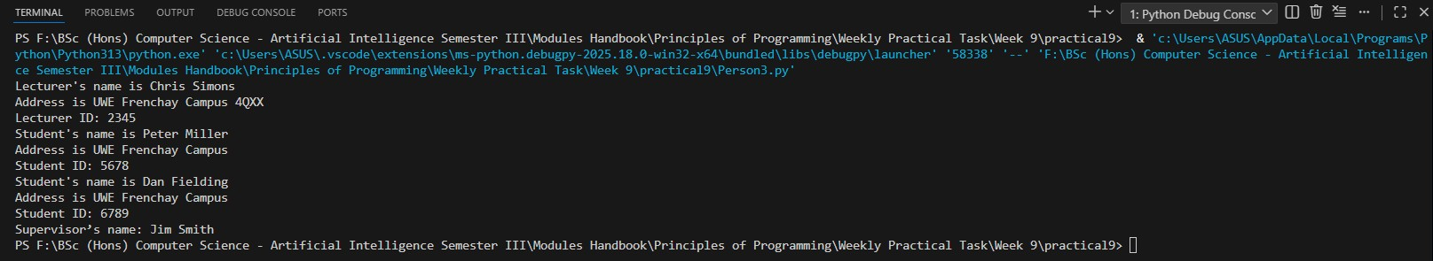

71
25024649
13.
Task 2.4. If you want to practice more, extend your design and code by adding new classes. For example, UnderGradaute (sub-class of Student), PermanentLecturer (sub-class of Lecturer), PartTimeLecturer (sub-class of Lecturer), HRStaff (sub-class of Person), and Accountant (sub-class of HRStaff). Draw the UML diagram for the classes and then implement them. Design them appropriately considering their appropriate member variables and methods.

Answer:
UML Diagram for all classes:
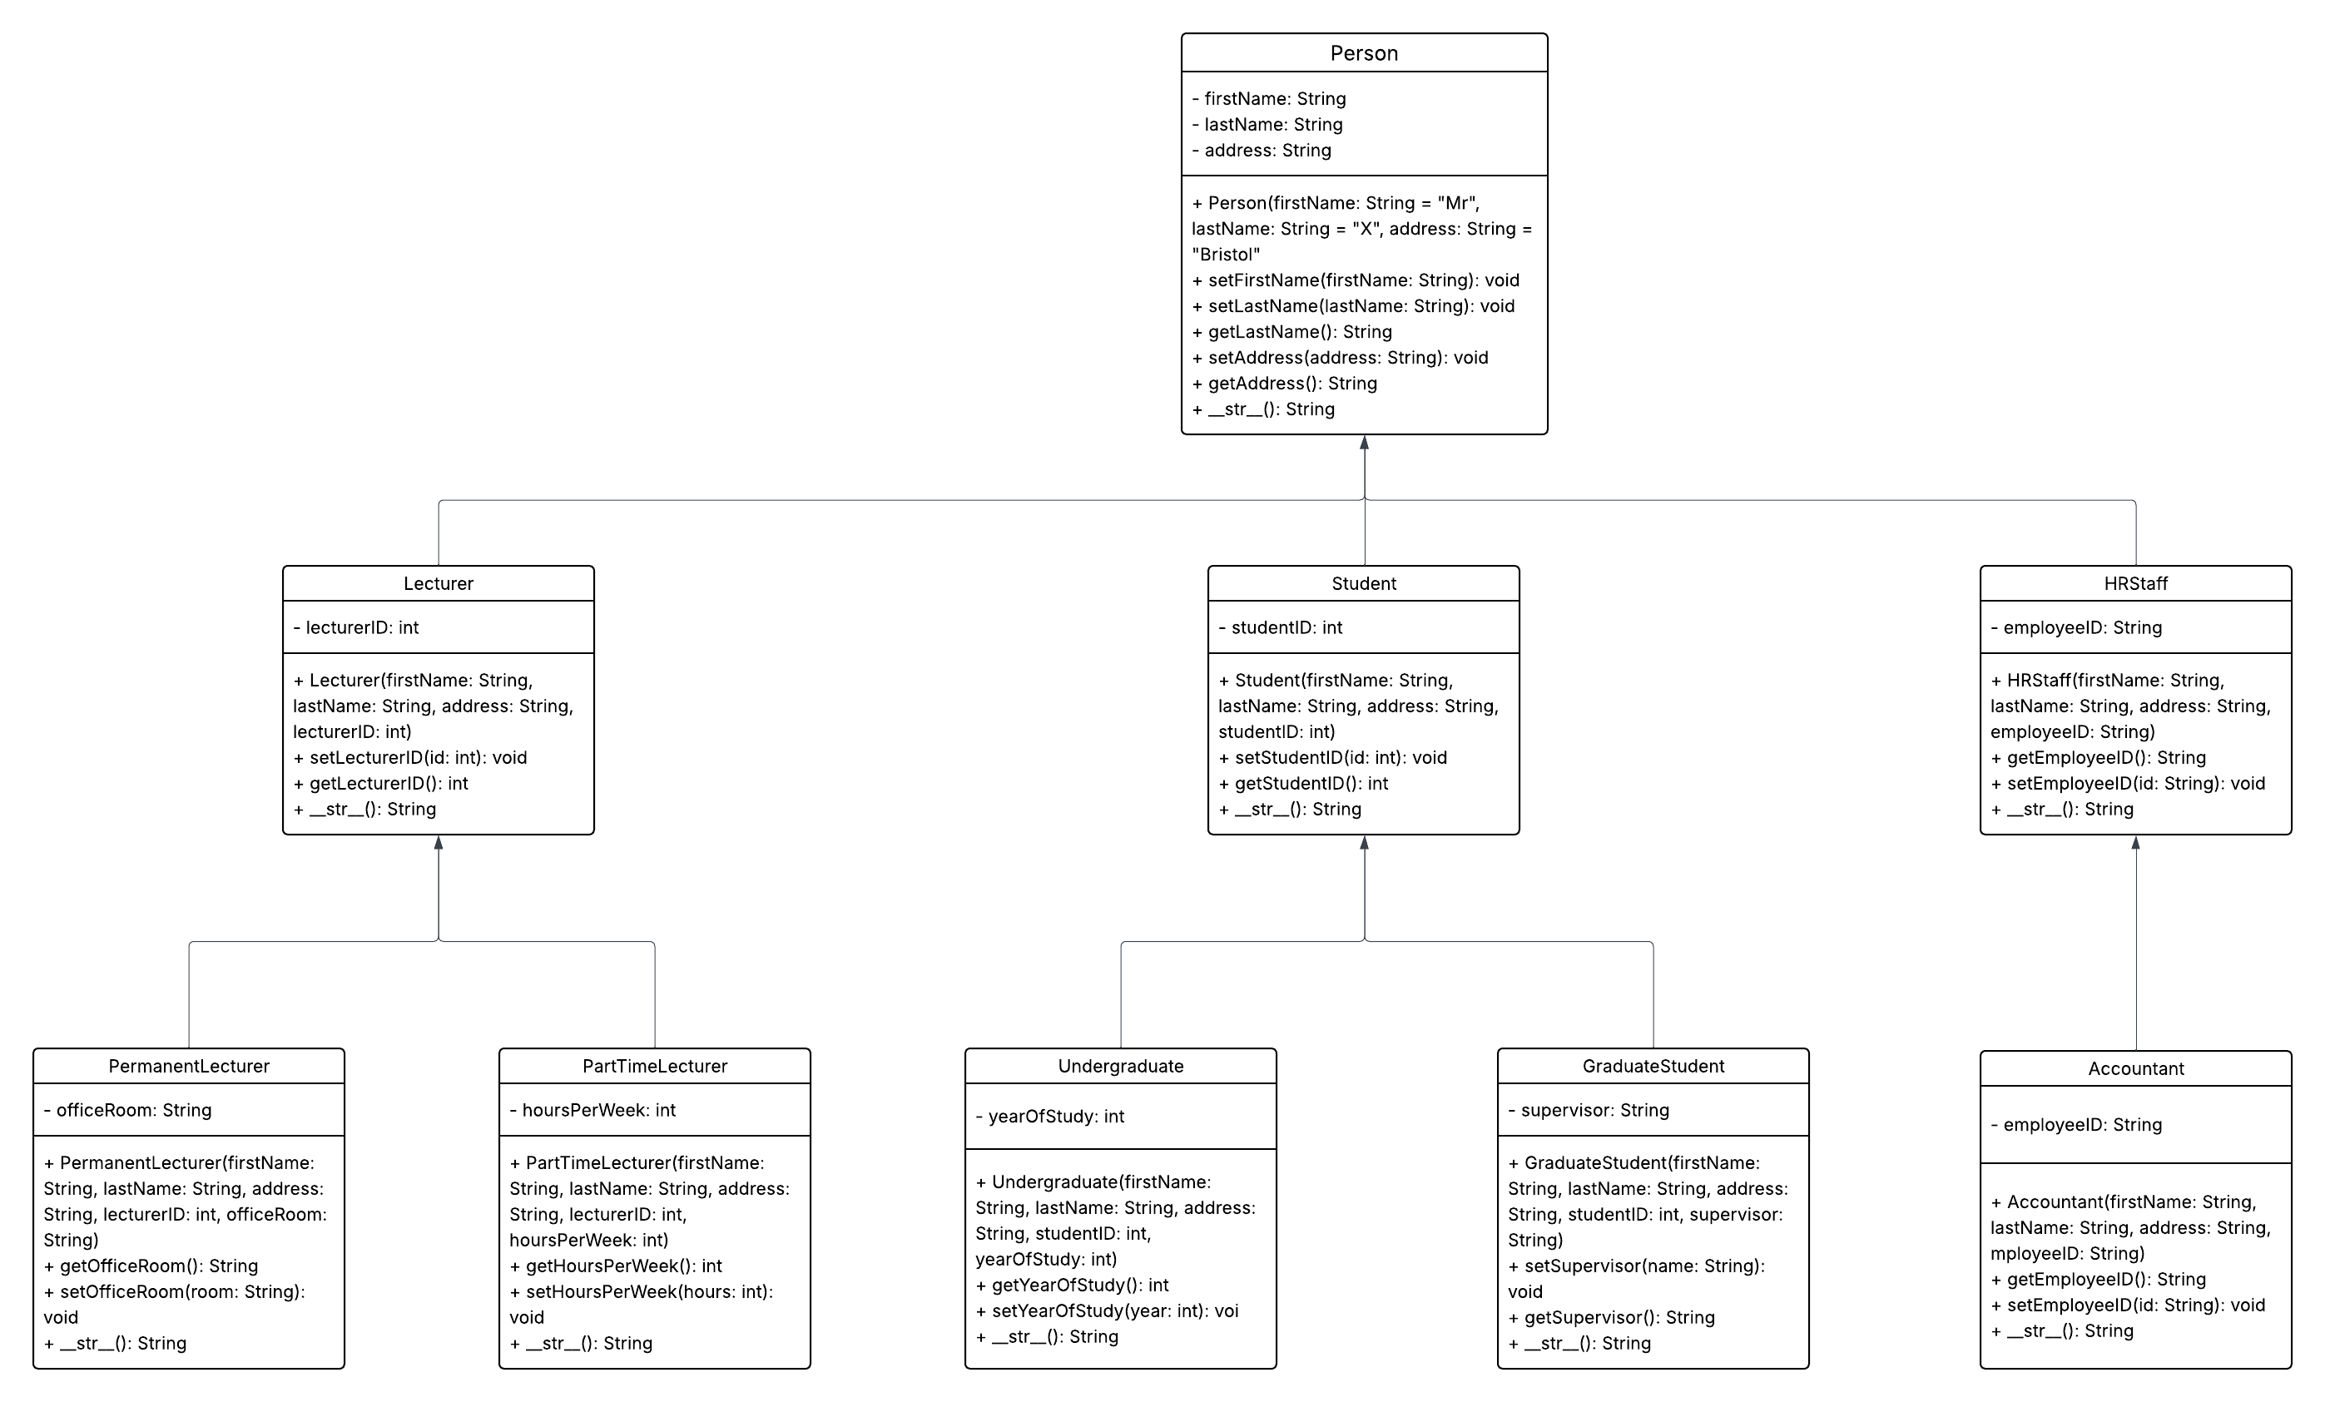
72
25024649
Answer:
Following code for input:
# Implementation of complete hierarchy for Person class
# Adding new classes.
# For example, UnderGradaute (sub-class of Student), PermanentLecturer (sub-class of Lecturer),
# PartTimeLecturer (sub-class of Lecturer), HRStaff (sub-class of Person), and Accountant (sub-class of HRStaff)

class Person:
def __init__(self, firstName="Mr", lastName="X", address="Bristol"):
self.__firstName = firstName
self.__lastName = lastName
self.__address = address

# Getters
def getFirstName(self):
return self.__firstName
73
25024649
def getLastName(self):
return self.__lastName

def getAddress(self):
return self.__address

# __str__ method
def __str__(self):
return (f"Person's name is {self.getFirstName()} {self.getLastName()}\n" f"Address is {self.getAddress()}")

class Lecturer(Person):
def __init__(self, firstName, lastName, address, lecturerID):
super().__init__(firstName, lastName, address)
self.__lecturerID = lecturerID

74
25024649
# Getters and setters
def getLecturerID(self):
return self.__lecturerID

def setLecturerID(self, lecturerID):
self.__lecturerID = lecturerID

def __str__(self):
return "Lecturer's name is " + self.getFirstName() + " " + self.getLastName() + "\n" "Address is " + self.getAddress() + "\n" "Lecturer ID: " + str(self.__lecturerID)

class PermanentLecturer(Lecturer):
def __init__(self, firstName, lastName, address, lecturerID, officeRoom):
super().__init__(firstName, lastName, address, lecturerID)
self.__officeRoom = officeRoom
# Getters and setters
def getOfficeRoom(self):
return self.__officeRoom
75
25024649
def setOfficeRoom(self, officeRoom):
self.__office = officeRoom

def __str__(self):
return "Lecturer's name is " + self.getFirstName() + " " + self.getLastName() + "\n" "Address is " + self.getAddress() + "\n" "Lecturer ID: " + str(self.getLecturerID()) + "\n" "Office Room: " + self.__officeRoom

class PartTimeLecturer(Lecturer):
def __init__(self, firstName, lastName, address, lecturerID, hoursPerWeek):
super().__init__(firstName, lastName, address, lecturerID)
self.__hoursPerWeek = hoursPerWeek

def getHoursPerWeek(self):
return self.__hoursPerWeek

def setHoursPerWeek(self, hours):
self.__hoursPerWeek = hours

76
25024649
def __str__(self):
return "Lecturer's name is " + self.getFirstName() + " " + self.getLastName() + "\n" "Address is " + self.getAddress() + "\n" "Lecturer ID: " + str(self.getLecturerID()) + "\n" "Hours per week: " + str(self.__hoursPerWeek)

class Student(Person):
def __init__(self, firstName, lastName, address, studentID):
super().__init__(firstName, lastName, address)
self.__studentID = studentID

# Getters and setters
def getStudentID(self):
return self.__studentID

def setStudentID(self, studentID):
self.__studentID = studentID

77
25024649
# Override __str__
def __str__(self):
return "Student's name is " + self.getFirstName() + " " + self.getLastName() + "\n" "Address is " + self.getAddress() + "\n" "Student ID: " + str(self.__studentID)

class Undergraduate(Student):
def __init__(self, firstName, lastName, address, studentID, yearOfStudy):
super().__init__(firstName, lastName, address, studentID)
self.__yearOfStudy = yearOfStudy

# Getters and setters
def getYearOfStudy(self):
return self.__yearOfStudy

def setYearOfStudy(self, year):
self.__yearOfStudy = year

78
25024649
def __str__(self):
return "Student's name is " + self.getFirstName() + " " + self.getLastName() + "\n" "Address is " + self.getAddress() + "\n" "Student ID: " + str(self.getStudentID()) + "\n" "Year of Study: " + str(self.__yearOfStudy)

class GraduateStudent(Student):
def __init__(self, firstName, lastName, address, studentID, supervisor):
super().__init__(firstName, lastName, address, studentID)
self.__supervisor = supervisor
# Getters and setters
def getSupervisor(self):
return self.__supervisor
def setSupervisor(self, supervisor):
self.__supervisor = supervisor

def __str__(self):
return "Student's name is " + self.getFirstName() + " " + self.getLastName() + "\n" "Address is " + self.getAddress() + "\n" "Student ID: " + str(self.getStudentID()) + "\n" "Supervisor’s name: " + self.__supervisor
79
25024649
class HRStaff(Person):
def __init__(self, firstName, lastName, address, employeeID):
super().__init__(firstName, lastName, address)
self.__employeeID = employeeID

# Getters and setters
def getEmployeeID(self):
return self.__employeeID

def setEmployeeID(self, employeeID):
self.__employeeID = employeeID

def __str__(self):
return "Employee's name is " + self.getFirstName() + " " + self.getLastName() + "\n" "Address is " + self.getAddress() + "\n" "Employee ID: " + str(self.getEmployeeID()

80

25024649
class Accountant(HRStaff):
def __init__(self, firstName, lastName, address, employeeID):
super().__init__(firstName, lastName, address, employeeID)
# No extra attributes

def __str__(self):
return "Employee's name is " + self.getFirstName() + " " + self.getLastName() + "\n" "Address is " + self.getAddress() + "\n" "Employee ID: " + str(self.getEmployeeID())

# Lecturer
lec = PermanentLecturer("Dr. Alice", "Brown", "Frenchay Campus", 1001, "Room 4B12")
print(lec)

# PermanentLecturer
perm_lec = PermanentLecturer("Prof. Cameron", "White", "Frenchay Campus", 102, "Room 5A10")
print(perm_lec)
81
25024649
# PartTimeLecturer
part_lec = PartTimeLecturer("Ms. Sarah", "Clark", "Frenchay Campus", 103, 15)
print(part_lec)

# Student
stu = Student("Harry", "Conway", "Frenchay Campus", 2024001)
print(stu)

# Undergraduate
ug = Undergraduate("Raj", "Sharma", "Frenchay Campus", 2024002, 3)
print(ug)

# GraduateStudent
gs = GraduateStudent("Liam", "Scott", "Frenchay Campus", 2024003, "Prof. Brown")
print(gs)

82
25024649
# HRStaff
hr = HRStaff("Sophia", "Lee", "Frenchay Campus", "Emp001")
print(hr)

# Accountant
acc = Accountant("Oliver", "Stone", "Frenchay Campus", "Emp002")
print(acc)

# Output:
# Lecturer's name is Dr. Alice Brown
# Address is Frenchay Campus
# Lecturer ID: 1001
# Office Room: Room 4B12
# Lecturer's name is Prof. Cameron White
# Address is Frenchay Campus
# Lecturer ID: 102
# Office Room: Room 5A10
# Lecturer's name is Ms. Sarah Clark
83
25024649
# Address is Frenchay Campus
# Lecturer ID: 103
# Hours per week: 15
# Student's name is Harry Conway
# Address is Frenchay Campus
# Student ID: 2024001
# Student's name is Raj Sharma
# Address is Frenchay Campus
# Student ID: 2024002
# Year of Study: 3
# Student's name is Liam Scott
# Address is Frenchay Campus
# Student ID: 2024003
# Supervisor’s name: Prof. Brown
# Person's name is Sophia Lee
# Address is Frenchay Campus
# Employee ID: Emp001
# Employee's name is Oliver Stone
84
25024649
# Address is Frenchay Campus
# Employee ID: Emp002

Output obtained in execution:
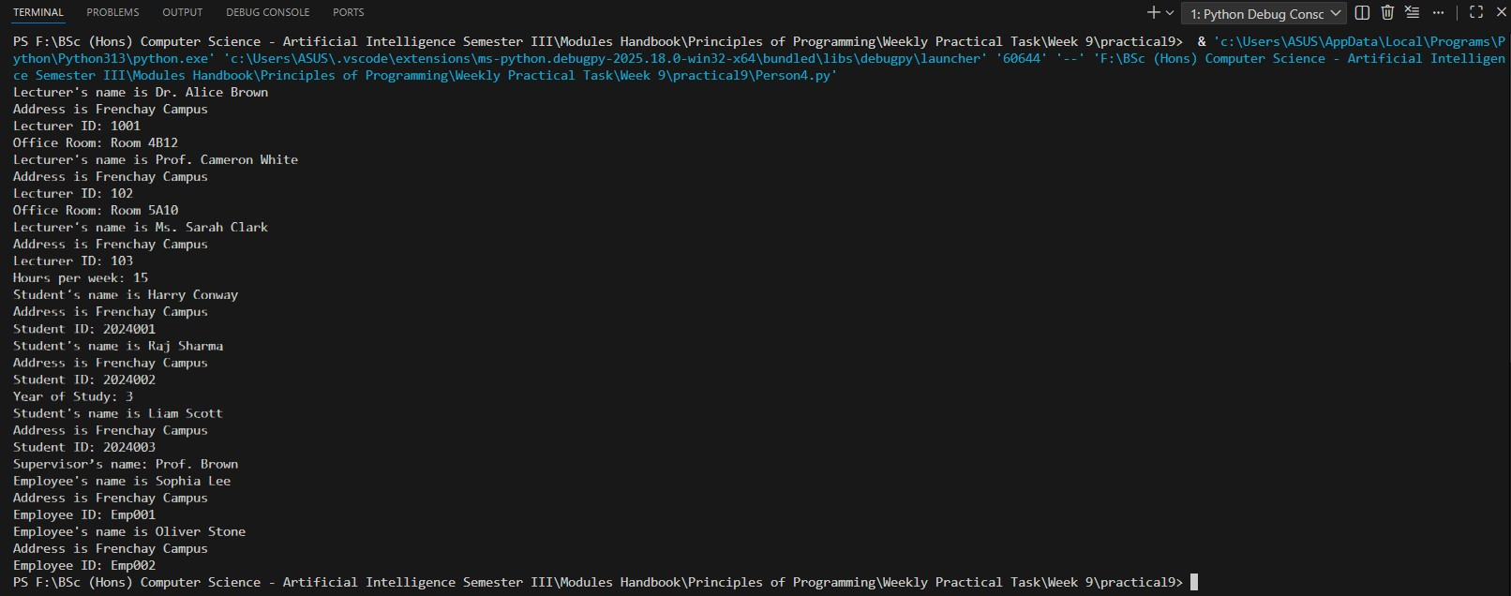
85

